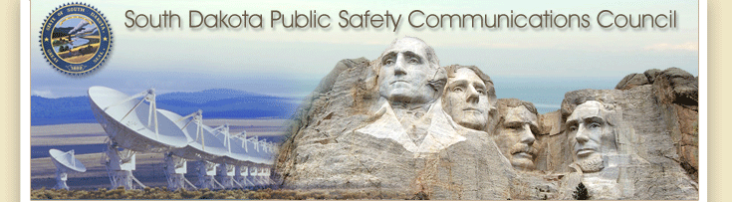

Annual Interoperability Report on Public Safety Communications in the State of South Dakota

Submitted by Matt Tooley
Chairman, South Dakota Public Safety Communications Council
December 23rd, 2016

Executive Summary

The South Dakota Public Safety Communications Council (SDPSCC) was created by Executive Order 2007-05 on March 14th 2007 with the following directive:

"The South Dakota Public Safety Communications Council shall foster collaboration among stakeholders at the local, federal, and state level."

The communications landscape has been permanently changed with the construction of the statewide radio network. Previously the state-supported communications system primarily supported state users and traffic. The current system user base has 12% federal/tribal, 22% state, and 64% local participation by radio count. It has become more important that ever to integrate the views and needs of all users on the network.

Appointed to the PSCC are the following individuals:

Dave Kull (Brandon Police) -- SD Police Chiefs Association
Dave Ackerman (Sheriff, McPherson County) -- SD Sheriff's Organization -- Executive Board
Dan Satterlee -- SD Division of Criminal Investigation
Bruce Nachtigall -- SD Game, Fish, and Parks
Brad Maupin (Director of Operations) -- SD Department of Transportation
SSG David Goodwin-- SD National Guards
Harold Timmerman (Lincoln EM) -- SD Emergency Managers Association
Dennis Gorton (Pennington Co Fire Director) -- SD Firefighters Association
Scott Duke -- SD Association of Healthcare Organizations
Matt Tooley (Metro Communications) -- SD APCO/NENA Chapter -- Chairman
JD Geigle -- SD Emergency Medical Technicians Association -- Vice Chairman
Paul Reiter -- Great Plains Interagency Fire Center
Bob Wilcox -- SD Association of County Commissioners
Rick LaBrie -- SD Department of Health
Chris Saunsoci (Chief of Police) -- Yankton Sioux Tribe
Andy Barth (US Forest Service) Federal
Jeff Pierce (Engineering Manager) SD BIT -- Executive Board
Casey Collins -- SD Department of Public Safety

The SDPSCC has met four times in Pierre during the 2016 calendar year: March, June, September, and December. The subject of updating the statewide radio network has been a primary focus this year. Other important agenda items covered included the Public Safety Broadband Network (FirstNet), replacement of substandard towers, consistent messaging regarding the system, 700 MHz state plan, and funding sources for additional tower sites.

South Dakota can take pride in the fact that our state has one of the most comprehensive communications systems for first responders in the country. We have approximately 98% geographic coverage and nearly every local, tribal, federal, and state first responder has a radio capable of establishing communications instantly.

Table of Contents

Executive Summary 2
Table of Contents 3
Purpose 4
Introduction 4
2016 SD Interoperable Communications System Report 4
Update Protocols and standards 4
Develop strategies and recommendations 5
Develop recommendations for legislation or other state action 5
Develop recommendations and strategies for best utilization of grant funding 5
Support Efforts of the 700 Mhz committee. 5
National Public Safety Broadband Network 5
Statewide Radio Network 6
Wireless Data Networks 9
Regional Communications 9
Conclusion 10

Purpose

As required by the bylaws of the SDPSCC: (5) prepare and submit an annual report to the Governor, the BIT Commissioner, and others as necessary on the status of communications interoperability in the state;

Introduction

The State of South Dakota recognizes the importance of communications interoperability within our state. As a rural state, we rely upon multi-agency response and shared resources to cooperatively provide for the public's safety.

This report serves to update the Governor, BIT Commissioner, and others on the progress of the SDPSCC on the following charges outlined in Executive Order 2007-05.

- Update Protocols and standards for the operation and use of the South Dakota Interoperable Communications System
- Develop strategies and recommendations to improve current and future operations of the radio network
- Develop recommendations for legislation or other state action that may be required to further promote public safety communications in South Dakota
- Develop recommendations and strategies for best utilization of grant funding to improve communications in South Dakota.

2016 SD Interoperable Communications System Report

The progress of the PSCC is not limited to the responsibilities charged to it in the introduction above, but this report will concentrate on those points and then provide a general technical and statistical overview of the network, and other communications activities.

Develop strategies and recommendations to improve current and future operations of the radio network.

Radio System Upgrade. In concert with the system vendor and associated lifecycle planning, the current trunking network with the upgrades in 2013 and 2014 was projected to be supportable through 2025. In March of 2016, the system vendor provided notice that the model of radio that they provide and is the prevalent model in use throughout the state will not have upgrade capabilities offered beyond December 31st 2017. This announcement put system administrators and radio users alike in a difficult position. Any update to the system after the end of 2017 without these radios upgraded prior to that upgrade will require that those radios be replaced at a substantial cost.

Develop recommendations for legislation or other state action that may be required to further promote public safety communications in South Dakota.

The council endorsed the inclusion of an additional $3,000,000 per year into the requested budget for BIT/State Radio for the 2018 fiscal year to upgrade the radios on the network, the network itself, and add additional sites to better cover underserved areas. It was clearly understood that this was a difficult year economically for state government, but the council clearly felt that this was a cross-discipline need and that it needed to be endorsed by the advisory board.

Develop recommendations and strategies for best utilization of grant funding to improve communications in South Dakota.

Homeland Security grants are approximately 10% of the amount received in 2004. With that in mind, the council has been judicious in recommendations not only for the network, but also in any policies that affect users of the system who might rely on grant funds to meet those policies. While our focus in the past was on providing additional coverage for system users, with the upgrade capability of the XTL/XTS series of radios from Motorola not available after the end of 2017, our focus will need to move towards radio replacement for those no longer able to be updated.

Support Efforts of the 700 MHz committee.

Each state is tasked with the responsibility of developing a statewide plan for the 700 MHz spectrum allocated to each state. The SDPSCC is acting as the governance body for that committee. After several years involved in the application process, our plan has received FCC approval and is now complete.

National Public Safety Broadband Network

In keeping with the mission of the SDPSCC and its service to Public Safety Communicators across the state, the council is also serving as the governance for the National Public Safety Broadband Network (NPSBN), also known as the FirstNet project. The council has been providing oversight and guidance for outreach and data-collection activities within the state.

Statewide Radio Network

System

The current radio system serving the State of South Dakota was offered for service in October of 2002. The system at that time had 35 regional sites, approximately 9,000 radios, and covered 90% of the geography of the state. (See below map)

Over the course of the past12 years, and additional 22 sites have been installed, and over 14,000 radio ID’s have been added to the network. The current system has 57 sites on line, 268 voice repeaters, and now exceeds 98% of the geography of the state. (See below map)

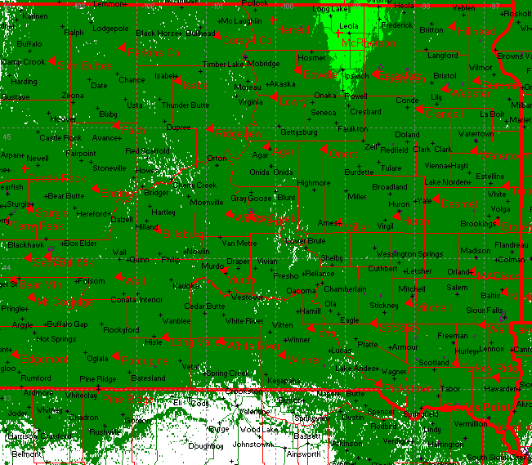

During the course of the current calendar year (January -November) the system has shown:
- 24,914,799 radio calls over the network, up from 23,512,796 in 2015.
- 74,372 radio calls on the average per day up from 70,397 in 2015.
- 2,742,141 radio calls over the Sioux Falls Simulcast up from 2,200,209 in 2015.
- 70,331 radio calls over the Slim Buttes (Harding County) up from 54,756 in 2015.
- 2,548,274 radio calls during the busiest month -- August up from 2,325,225 in 2015.

System Statistics
Radio Users (24,729 Total Radio ID’s)

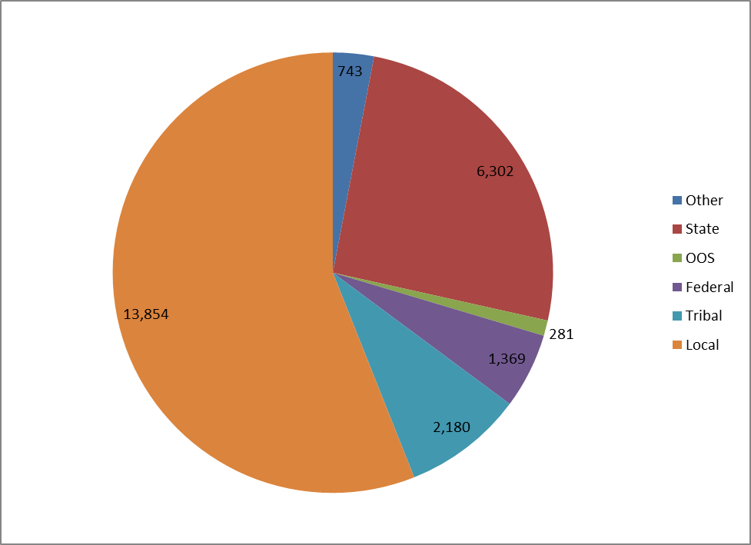

System Use Percentages 2015
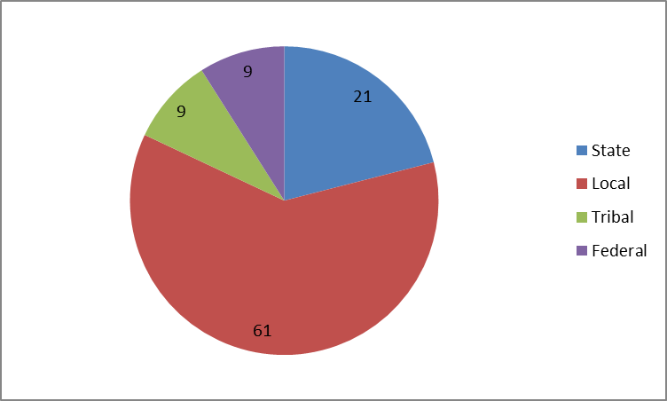

Improvements made in 2016 to the network:

- Upgrading of tower lighting systems. A number of sites were upgraded from the legacy incandescent lighting to LED lighting systems. These upgraded lighting systems are more energy efficient and in most cases remove the painting requirement for towers.
- Tested and replaced defective antenna systems statewide. In many cases the antennas associated with our statewide system have been in place since turn-up in 2002 and have suffered water or other environmental-related damage. Replacing these systems has improved network performance statewide.
- Replaced tower at the McLaughlin (Corson) site because original tower was in failure.

Areas underserved designated by council as priority that need to be addressed at some point:
- Union County, southern part of county is not well served by current sites.
- Chamberlain, Presho, Kennebec areas.
- Hot Springs area, work to improve coverage.

Notable events during 2016:
- The tower at the McLaughlin (Corson) site was replaced and the procurement for replacement of the Madison site was completed. Madison tower will be replaced in calendar year 2017.
- Christmas day storm. This storm affected sites across the state with snow, ice, and wind. During the course of the storm we had 19 sites with commercial power affected that relied on generators to keep the sites on the air.
- Announcement by Motorola that support was being discontinued for the XTS/STL series of radios. Long-term planning had steered State Radio to a 2025 refresh, this may have affected that timeline.
- 700 MHz plan approved by FCC. State is now completed with this process.
- The WAVE application process was started. When completed this will allow smart-phone users to utilize those devices to access the radio system for non-critical services.
- Radio system network control was upgraded to version 7.15. We are now down to two possible upgrades before we will have to transition to Project25 (P25) for any further updates.

State Radios
Most radios in used by state agencies have been upgraded over the past 5 years and many have the P25 flash included. We will need to identify all radios without this flash which will not be available after 2017, and begin prioritizing those for replacement.

Local Radios
The Motorola discontinuation of support for the P25 upgrade option has a big effect on local agencies. There is currently an effort underway to identify those radios not purchased with the P25 flash, and prioritize those for replacement. State Radio technicians continue to work with local agencies on user training.

Tribal/Federal Radios
The BIT State Radio staff does provide limited technical assistance with the federal and tribal radios operating on the statewide system, but they are generally are self-maintained. State Radio technicians are working with tribal and federal technical support to inventory and update radios to P25 as well as user training upon request.

Wireless Data Networks

The passage of the Middle Class Jobs Creation Act of 2012 included an outline and initial funding for a nationwide public safety high-speed data (broadband) network, or the National Public Safety Broadband Network (NPSBN). When implemented the system will use commercial standard technology (LTE), and will offer a standard data platform for users across the country. An organization (FirstNet) has been set up under the US Department of Commerce to administer the system.

South Dakota has been preparing for the network by establishing a Point of Contact and backup (Jeff Pierce and Matt Tooley), Project Manager (Mike Waldner) and designation of the South Dakota Public Safety Communications Council as the representative governance. South Dakota was awarded a grant in the amount of $1,217,103, with an expected match amount of $309,708 to provide outreach, education, and data through February 2018 for the ultimate rollout of the nationwide public safety broadband system.

A significant amount of time was spent during 2016 working with associations to update those groups on status of the project. An expected RFP award in December to announce the selected vendor for the buildout has been delayed due to a legal challenge by one of the vendors that was eliminated from the competition.

The South Dakota team has also been attending state association meetings and national meetings organized to keep the state teams informed.

Regional Communications

State technical staff has been engaged with bordering states for many years working on cross-border communications. State Radio technicians have been installing repeaters along the border which will enable at minimum dispatch to dispatch communications with the intent on improving unit to unit communications. During the calendar year 2016, State Radio worked with the National Weather service to develop a communications plan for the Sioux Falls office, including counties in South Dakota, Iowa, Minnesota, and Nebraska.

The States of Wyoming, Montana, North Dakota, Minnesota, and Iowa have all installed or are in the process of installing networks that would be compatible to the system upgrade being considered in South Dakota. Cross-border interaction of first responders in the Emergency Medical Service, fire, and law-enforcement disciplines is routine and better communications will only improve public safety. South Dakota currently has 281 ID’s issued to border state first responders to improve interoperability.

First responders from across the state are participating in a FEMA Region 8 working group on interoperable communications (RECCWG). John McQuillen from the Brown County dispatch center, Cari Leidholt from SD Emergency Management, and Jeff Pierce with the Bureau of Information & Telecommunications are representing our state well in this group.

Public Law 110-53 also requires each state to have a full-time interoperability coordinator or equivalent. Jeff Pierce from the SD Bureau of Information & telecommunications is currently serving this function and is part of a national group working on communications both in-state and nationally.

Conclusion

South Dakota maintains one of the more comprehensive communications systems from a coverage and participation standpoint in the nation. It has taken the trust of our entire first-responder community, and a willingness to understand that in a rural state such as ours that nobody operates alone to accomplish this in our state.

We do have challenges ahead.
- We have known since 2013 that our system had a technical end of life around 2025. That schedule was pressed some this year as Motorola discontinued any sales support for equipment or options for the XTL/XTS series of radios, the most prevalent on the system. As those radios not upgraded to P25 capability by the end of 2017 will need to be replaced before the system can be upgraded, it has added a level of urgency to the concept of upgrading the system. The current plan is to prioritize any grant funding available to replacement any of radios not P25 capable.
- Our tower infrastructure is aging, with many sites constructed in the 1970’s under significantly lower engineering standards. We will be replacing the Madison tower during 2017 at an estimated cost of $150,000, but considering the size of our network and that these towers are regularly inspected, we may find more that are deficient.

The PSCC is pleased to report that interoperability in South Dakota is meeting the needs of our first responder community, and is advanced both regionally and nationally. We have challenges ahead to maintain that standing, and will need to maintain this as a priority within our state. Our council will strive to ensure that this progress continues.

