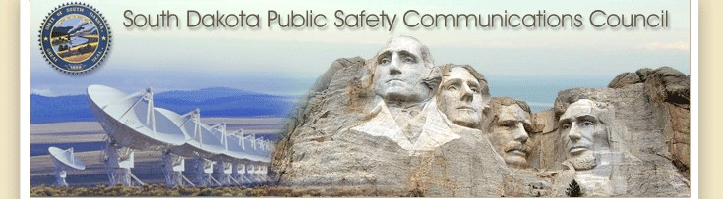

December 2022 Meeting (Postponed until January 31, 2023)

On-Line & 700 Governor’s Drive

12-13-2022

Meeting Will Begin 10:00 Central

# Agenda

Call to order – Chair Nachtigall

Roll Call of Members

Police Chiefs –Jason Jones

Sheriffs Organization – Steve Swenson

Division of Criminal Investigation – Chad Mosteller

South Dakota Game, Fish, & Parks – Bruce Nachtigall

South Dakota Department of Transportation – Tyler Green

South Dakota National Guards – David Goodwin

South Dakota Emergency Managers Association – Pat Harrington

South Dakota Fire Fighters Association – Charlie Kludt

South Dakota Association of Health Care Organizations – Tim Rave South Dakota Department of Public Safety – Garrett Wellman

South Dakota APCO/NENA Chapter – Kevin Karley

South Dakota Emergency Medical Technicians Association – JD Geigle

South Dakota Department of Public Safety/ Wildland Fire – Open

South Dakota Association of County Commissioners – Gary Jaeger South Dakota Department of Health – Chuck Kevghas

Tribal Government – SWST Emergency Manager – Jim Pearson Federal Government – Andy Barth

Bureau of Information and Telecommunications – Trent Nincehelser

911 Coordinator – Maria King

SD House – Vacant SD Senate – Senator John Wiik

Additional Agenda Items – SD House Vacancy

Approval of March meeting minutes -

**New Business**

1. **SWIC Updates** – Todd Dravland (SWIC South Dakota)
2. **System Upgrade Status.**
   * Completed, upgrade of system core to 2019.2
   * NICE recording system upgraded.
   * GenWatch3, a system diagnostic and reporting system has been installed and operational.
   * Critical Connect, the system interconnect, LTE interface, and PTT app is installed, tested, old WAVE system shut down, and is in beneficial use. Currently working on new user onboarding process.
   * The Edgemont site was upgraded to P25 on October 5th as a beta test site. The Rapid City Simulcast system upgrade was on October 21st, the upgrade process consisted of moving the prime site from Elk Vale Rd. location to Camp Rapid and is now co-hosted with the Pennington County back dispatch center with the redundant network connection shared with ROC. The new location leverages shared infrastructure already in place and increases survivability, security of the Rapid City Simulcast system. The system was left live in SmartZone operating at partial capacity during the upgrade with a total downtime for cutover of less than two hours.
3. **Hot Springs, & Hills projects outlines.**
   * Hot Springs, $400k, uses existing Battle Mountain tower & building. Improved coverage in Hot Springs & southern hills area. The new Hot Springs site is now operational and became active on October 5th, 2022.

1. **Redfield/White River Projects**
   * $600,000 for a new site at the Redfield DOT yard, work ongoing with DOT.
   * $150,000 for a replacement 250’ tower at White River
   * Spectrum analysis work completed
   * Working with Sabre for tower site work
   * Site construction anticipated for spring 2023 with target activation mid-2023.

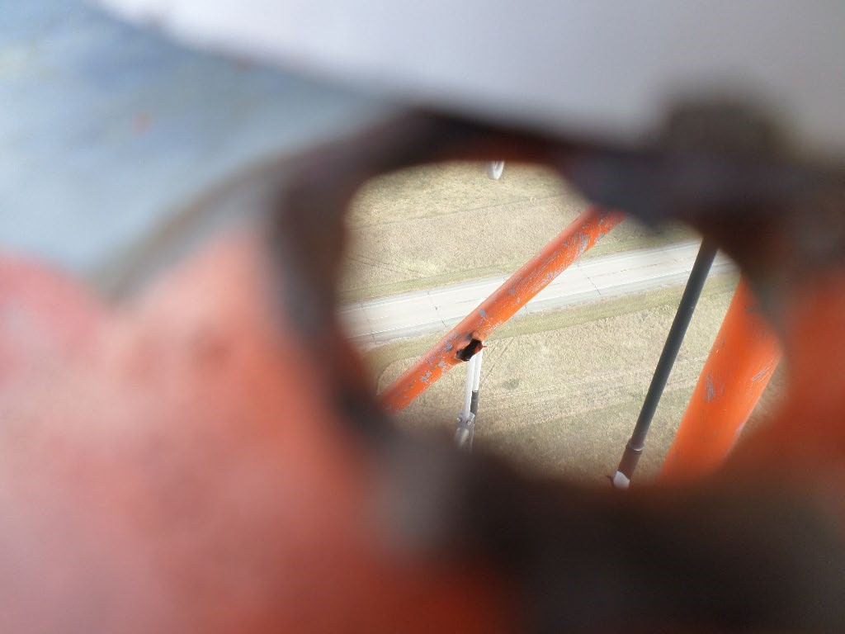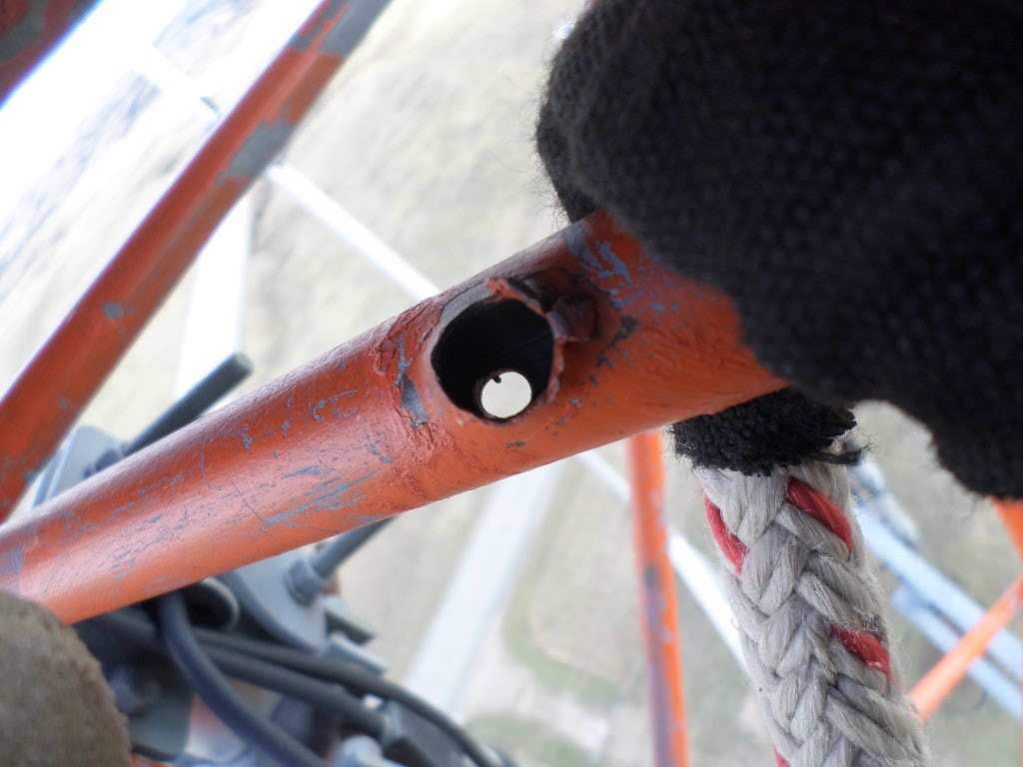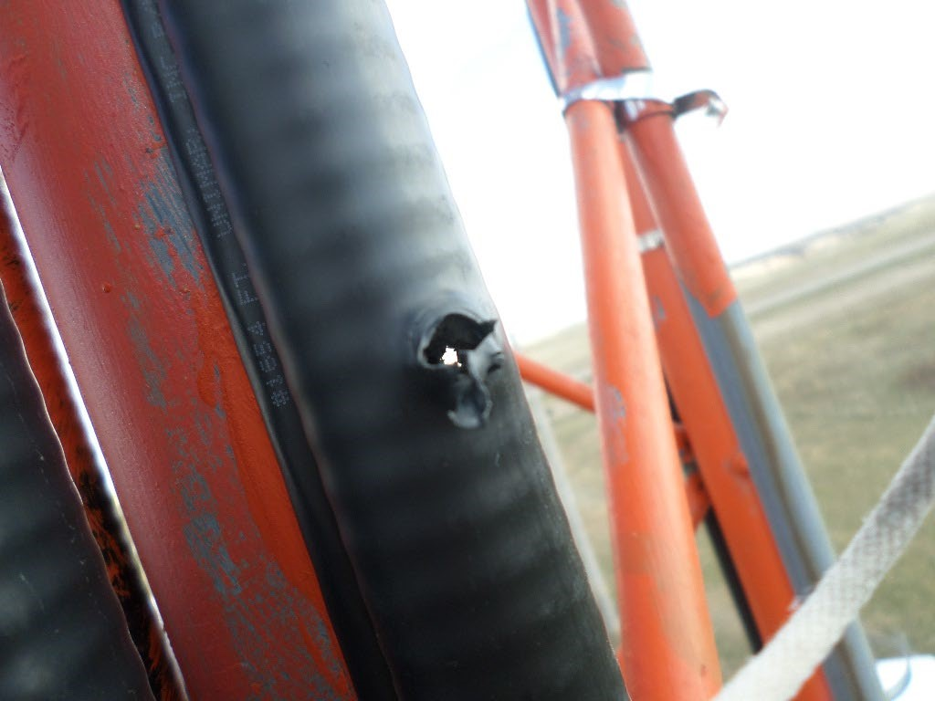

1. **Highway Patrol/State Radio mentorship and training exercise**

* On November 8th Highway Patrol and State Radio technicians participated in a mentorship/training exercise. HP technicians were provided with necessary programming cables, software, and encryption key loader, so they can better serve troopers. This enhanced collaborative relationship will benefit both state radio technicians and HP troopers limiting wait time and resources traveling to and from scheduled radio programming events. This effort and ongoing professional collaboration between the two groups of technicians will foster an environment for new product research and development, custom solutions, and enhanced support capabilities, ensuring Highway Patrol remains on the leading edge of mission critical communications solutions.

1. **Motorola SmartConnect Presentation (cancelled due to time constraints)**

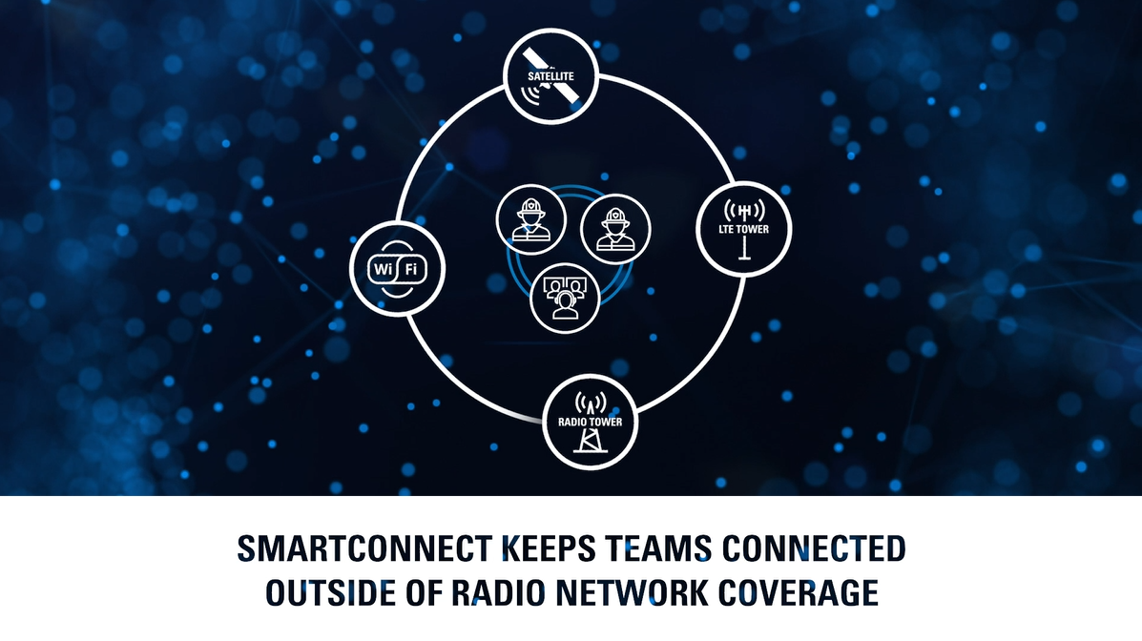

1. **Formula development for underserved state radio coverage areas – open discussion**

* Added to this meeting agenda per request at September 2022 meeting
* Identify unserved and underserved areas of state radio coverage
* Identify considerations and parameters to establish priority level of unserved and underserved areas
* Formula developed and adopted by SDPSCC will be used to request funding

1. **BIT Service Desk portal now live for all state radio service requests**

The BIT Service Desk portal is now available to contact BIT/State Radio at <https://servicedesk.sd.gov>. From this portal, you can report issues to BIT/State Radio by way of Incidents, search our Knowledgebase, make a request for new or modify existing services through our Service Catalog, and interact with BIT employees on incidents and requests directly.

Visit the BIT Service Desk portal at <https://servicedesk.sd.gov>, and click the following depending if you are a state user/agency or a non-state user/agency. If you are a state user/agency, simply click the “State Employee Login” button. For non-state users please proceed by following items 1-6 below.

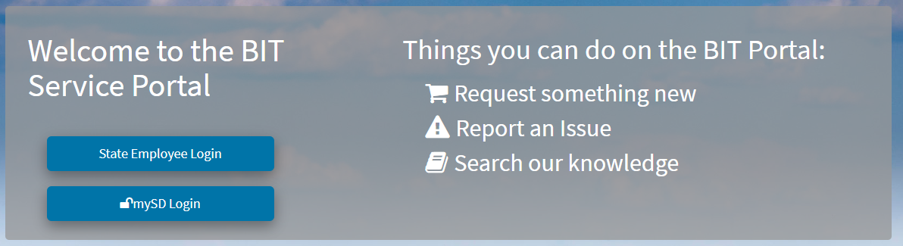

State users

Non-state users

1. If a Login Help screen appears, close it.
2. Enter the email address you want to use for the mySD Login and click **Continue**. On the bottom right section of the window, click the **Sign up now** link.
3. Click the **Send verification code** button.
4. Go to your email and check for a message from 'donotreply@state.sd.us'.
5. Copy the code you received in your email, enter it on the mySD page, and click 'Verify code.'
6. Complete the information on the screens that follow.

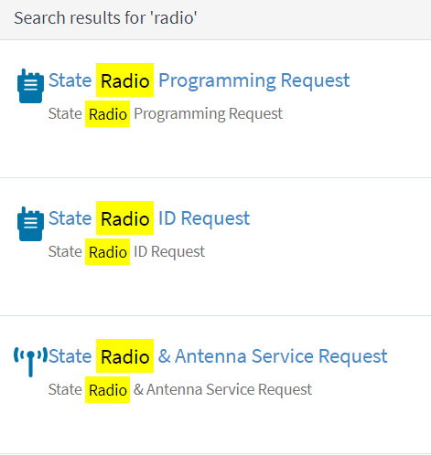

To request services from BIT/State Radio, you can then search requests for what you are looking for by using key words such as “radio”. If you cannot find the specific request you are searching for, then you can submit a “General Service Request”. Or you can submit an “Incident” to report issues for an unplanned interruption or reduction in quality of service provided by BIT/State Radio. After opening an Incident or Request, emails with updates on progress will come from BIT Service Desk [BITServiceDesk@state.sd.us](mailto:BITServiceDesk@state.sd.us). To interact with BIT/State Radio on our request or incident, you can open the link in the email to interact via the Service Desk portal or reply to the email. Replies to BIT Service Desk emails with the Ref: number at the bottom of the message are automatically inputted and associated with the Incident or Request you are referencing.

The BIT Service Desk is still available by phone at (605) 773-HELP. If you have a mySD login when you call, our Service Desk can associate the Incident or Request with you so you receive updates via email and can interact with BIT via the Service Desk portal.

1. **Minnehaha County projects**

* New dispatch
* Simulcast expansion

10. **PSAP/Dispatch engagement for radio stakeholders – Maria King, Kevin Karley**

* P25 Tower Site Conversions – Tips for Successful Cutover (see handout)

**Old Business**

**1. 2022/2023 Budget**

* + Reviewing items paid out of regular budget to make sure we are not paying project items out of our regular budget.
  + 23/24 budgets will be challenging.

*58% of FY23 budget year remaining with 56% funding remaining. 21% of total budget paid out in Contractual Services at the beginning of the fiscal year primarily to Motorola for ongoing projects.*

**2. Broadband Subcommittee Report**

* FirstNet buildout updates

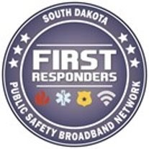

1. **Advanced System Key Policy** 
   * Review policy for Advance System Key distribution
   * Will need to adopt a policy to promote state radio system integrity, security, and affected stakeholders
2. **Encryption Standard**

* Technical assistance request has been made with CISA
* Working on scheduling an open state workshop on statewide administration
* Bi-weekly meetings with Pennington and Minnehaha County staff

**5. Strategy for P25 upgrades 2023**

* Effectively passing upgrade information to our affected agencies and organizations
* Action Item requested for council members to bring back agency/organization preparedness level for council review

Organizational Reports

Police Chief’s Assn. - Jason Jones

Sheriffs Assn. - Steve Swenson

DCI - Attorney General – Chad Mosteller

GFP - Bruce Nachtigall

DOT-Tyler Green

National Guard - David Goodwin

Emergency Managers - Pat Harrington

Firefighters - Charlie Kludt

Healthcare - Tim Rave

Dept. of Public Safety - Garrett Wellman APCO/NENA - Kevin Karley

EMT’s - JD Geigle

Wildland Fire/DOA - Vacant

County Commissioners - Gary Jaeger Health Dept.- Chuck Kevghas

Tribal Governments - Jim Pearson Federal Government - Andy Barth

BIT Engineering - Trent Nincehelser

911 - Maria King

SD House – Vacant

SD Senate - John Wiik

Closing Comments

Vice-chair – Garrett Wellman

Member at Large - Kevin Karley

Chair – Bruce Nachtigall

Next Meeting: date, time, location. December timeline