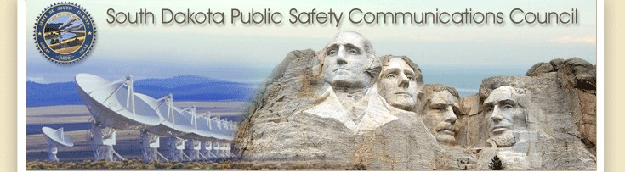

June Meeting

Zoom Meeting & 700 Governor’s Drive

6-14-2023

Meeting Will Begin 10:00 Central

# Agenda

Call to order – Chair Nachtigall

Roll Call of Members

Police Chiefs –Jason Jones

Sheriffs Organization – Steve Swenson

Division of Criminal Investigation – Chad Mosteller

South Dakota Game, Fish, & Parks – Bruce Nachtigall

South Dakota Department of Transportation – Vacant

South Dakota National Guards – David Goodwin

South Dakota Emergency Managers Association – Pat Harrington

South Dakota Fire Fighters Association – Charlie Kludt

South Dakota Association of Health Care Organizations – Tim Rave South Dakota Department of Public Safety – Garrett Wellman

South Dakota APCO/NENA Chapter – Kevin Karley

South Dakota Emergency Medical Technicians Association – Brent Long

South Dakota Department of Public Safety/ Wildland Fire – Ray Black

South Dakota Association of County Commissioners – Gary Jaeger South Dakota Department of Health – Chuck Kevghas

Tribal Government – SWST Emergency Manager – Jim Pearson Federal Government – Andy Barth

Bureau of Information and Telecommunications – Trent Nincehelser

911 Coordinator – Maria King

SD House – Vacant SD Senate – Senator John Wiik

Additional Agenda Items – Curt Rees Retirement – Thank you for your service to radio users in South Dakota!

Approval of March meeting minutes -

**New Business**

1. **SWIC Updates** – Todd Dravland (SWIC South Dakota)
2. **System Upgrade Status.**
   * Permit Challenges update – Permit has been issued and construction is completed at Bear Mountain. White River is still a challenge, and we will be working on contingency plan for microwave solution soon.
   * Site upgrades completed for all direct connected PSAP/Dispatches and the following tower sites are now completed
   * Visit [STATERADIO.SD.GOV](https://stateradio.sd.gov/) to track P25 upgrades

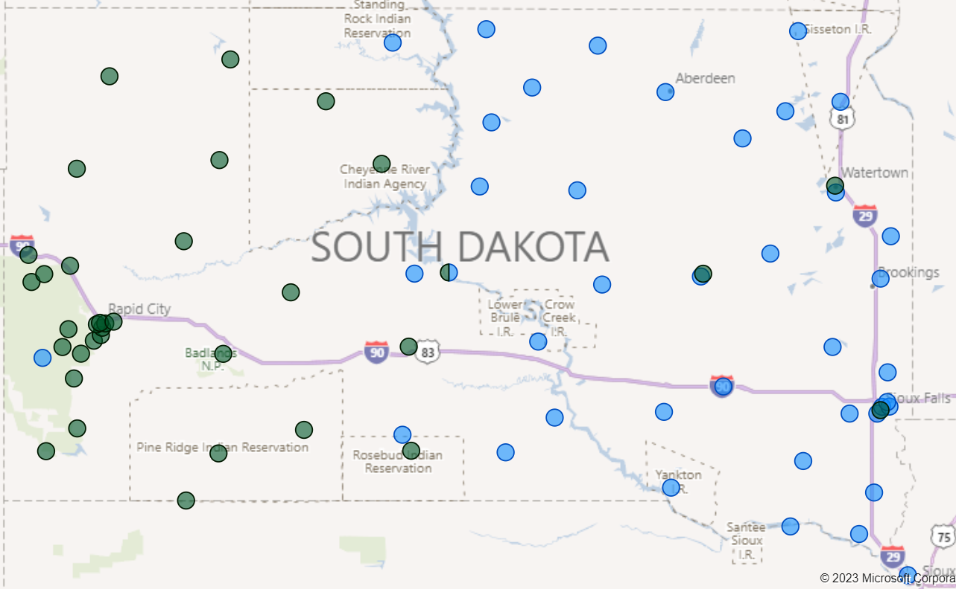

1. **Motorola Futurecom DVRS Presentation**

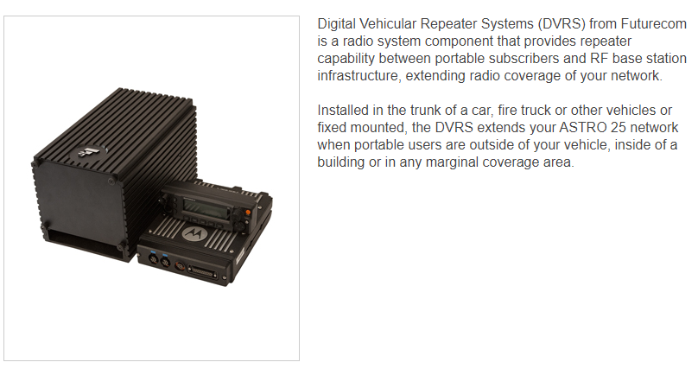

1. **Redfield/White River Projects**
   * The new site at the Redfield work has been delayed by wet site conditions and unknown sand-filled void discovered while excavations under the original planned tower site.
   * New soil analysis tests to be performed at new proposed tower site adjacent to east side of the building. Spectrum has been licensed for the site, Motorola equipment has been received, antenna and feedlines have been received, generator is on order, and electrical work is completed at the site. New target date set for the Fall of 2023.
   * The 250’ tower replacement at White River is now completed, tower has been erected and the old tower has been deconstructed and hauled away.

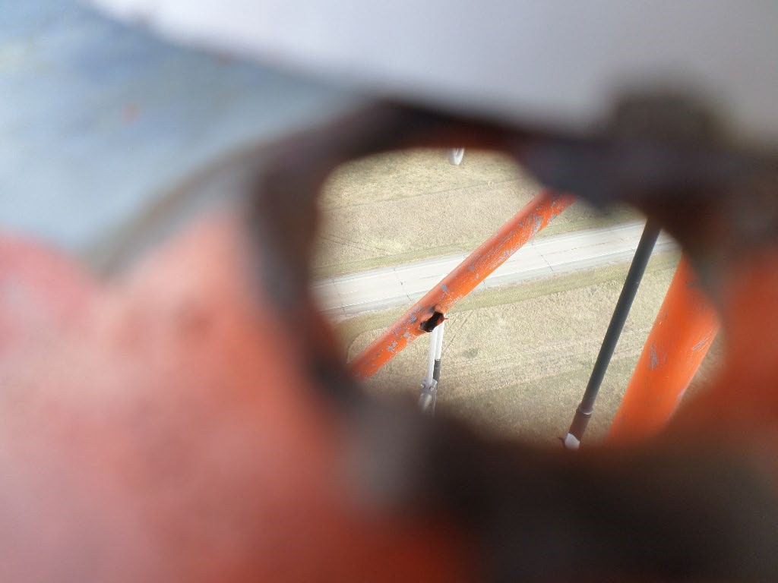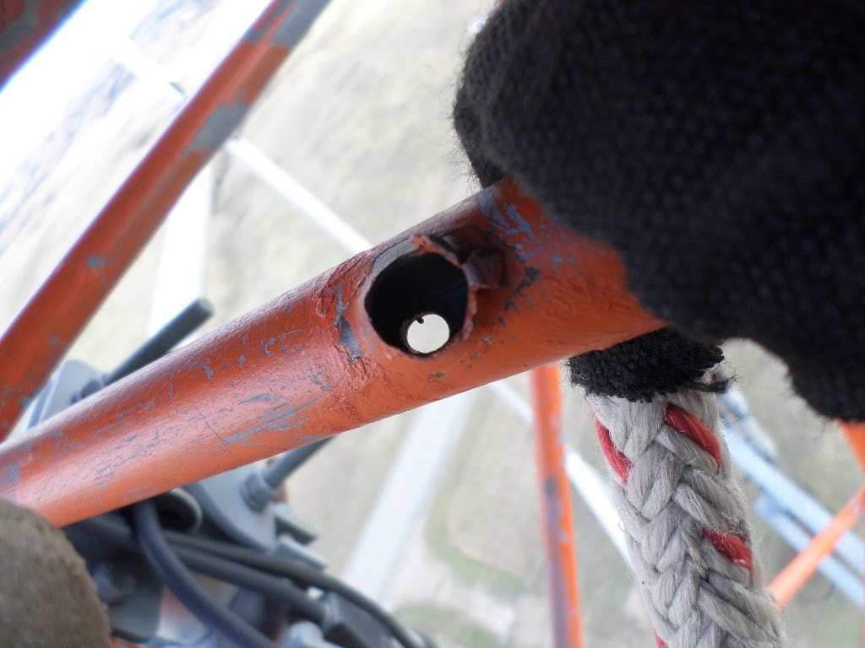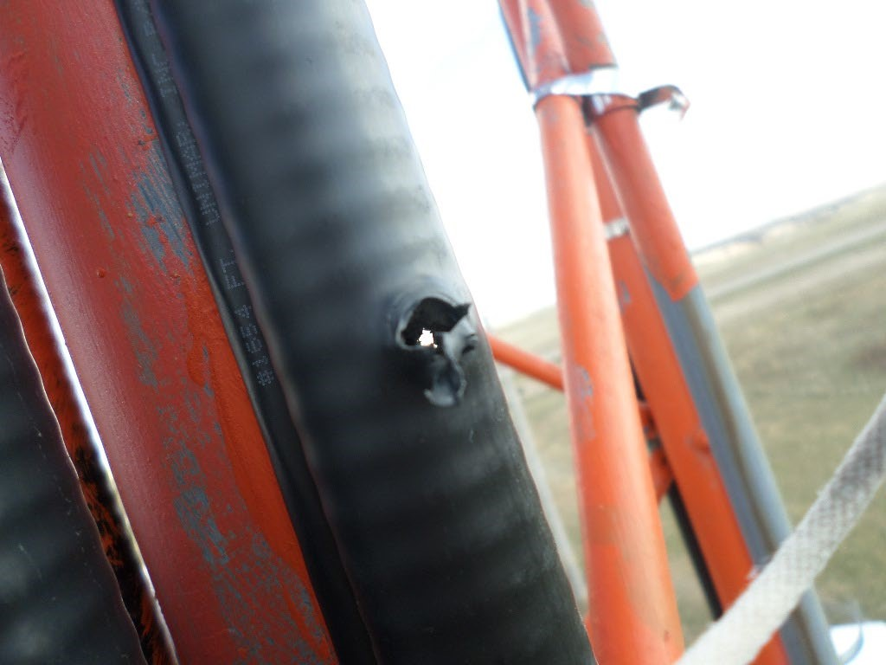

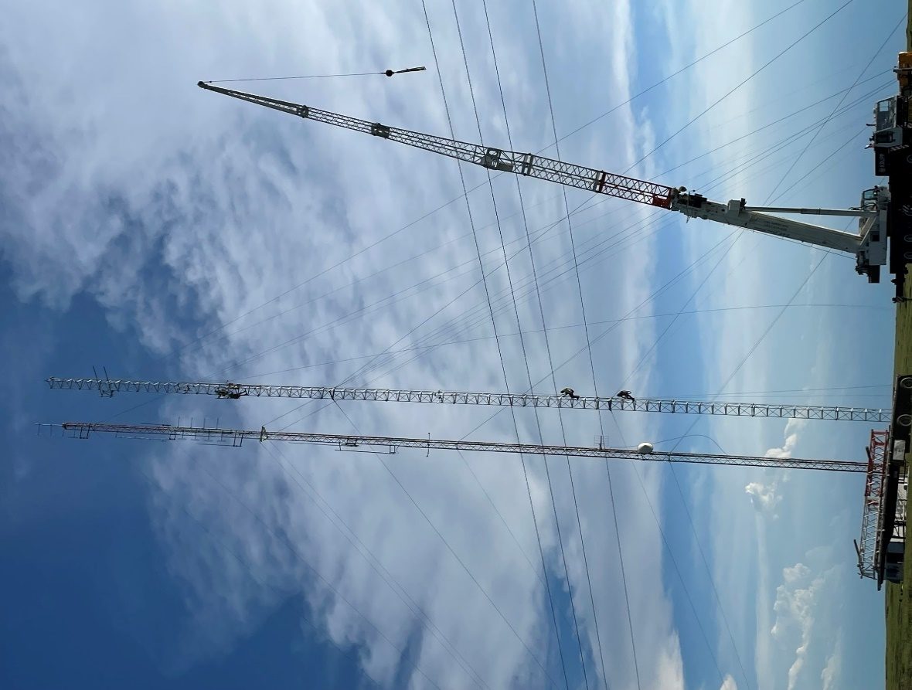 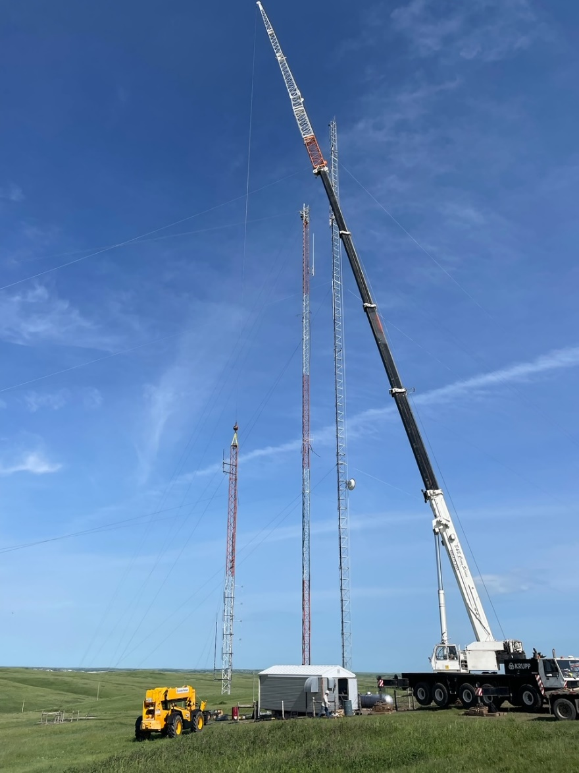

*Crews climbing new tower to install feedline and antennae and the beginning of deconstruction of old tower*

1. **Formula development for identifying underserved state radio coverage areas – open discussion**

* Added to this meeting Agenda per request at September 2022 meeting
* Identify unserved and underserved areas of state radio coverage
* Identify considerations and parameters to establish the priority level of unserved and underserved areas
* The formula developed and adopted by SDPSCC will be used to request funding
* A group was formed consisting of Nincehelser, Nachtigall, Pearson, Harrington, and Karley to identify the parameters used in identifying underserved areas for State Radio coverage in the state
* The results of the meetings were that we identified several different parameters to consider represented by the table below

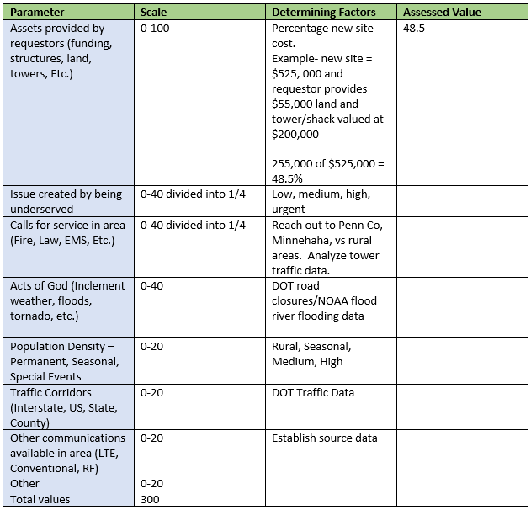

1. **Minnehaha County Projects – Matt Tooley**

* New Dispatch
* New simulcast system

1. **Talkgroup Access Permission Form and Cache Radio Policy Review**

* Review and offer open discussion/suggest modifications
* Intend to move to adopt in September meeting

**Old Business**

1. **Budget**

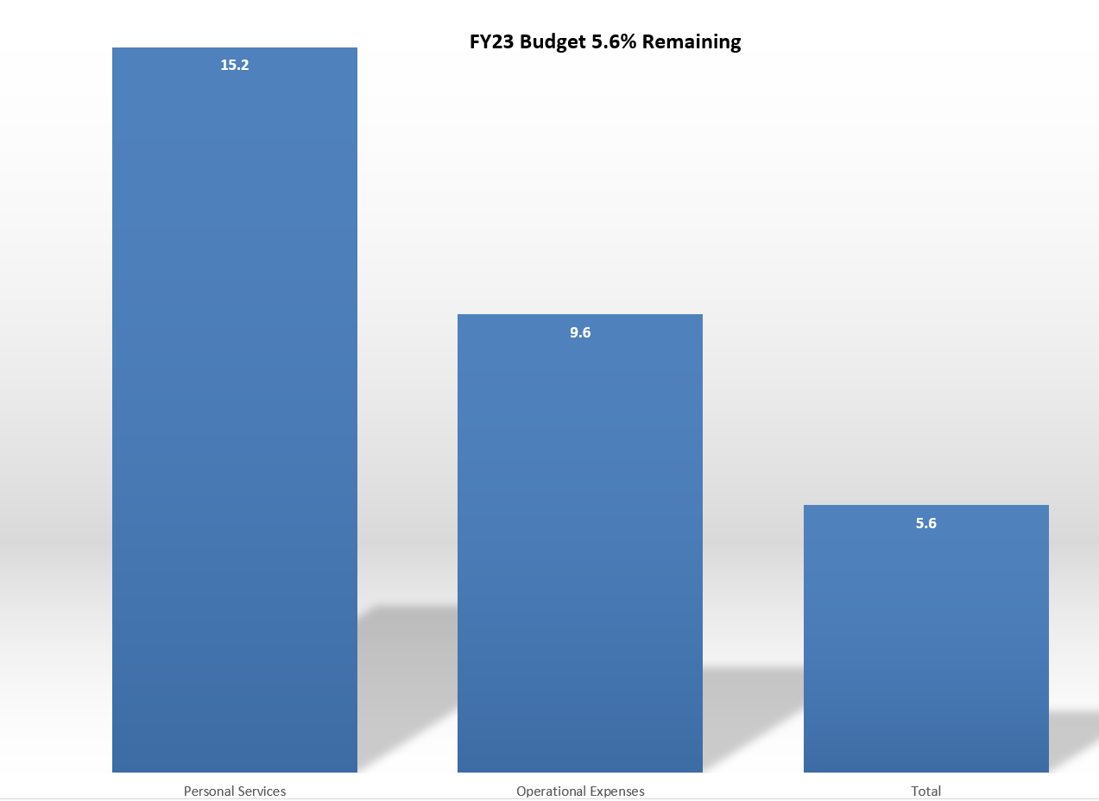

6*% of FY23 budget year remaining with 5.6% funding remaining. 21% of total budget paid out in Contractual Services at the beginning of the fiscal year primarily to Motorola for ongoing projects.*

1. **Broadband Subcommittee Report – Kendall Light**

* FirstNet Buildout Updates
* FirstNet Tower Needs spreadsheet *see example below

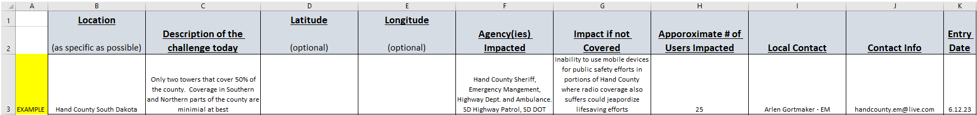

1. **Organization representative vacancies**

* DOT – DOT is in process of hiring staff member to replace
* SD House

1. **5 Year Plan Review**

* Added 2 additional item to 2023 per last meeting discussion

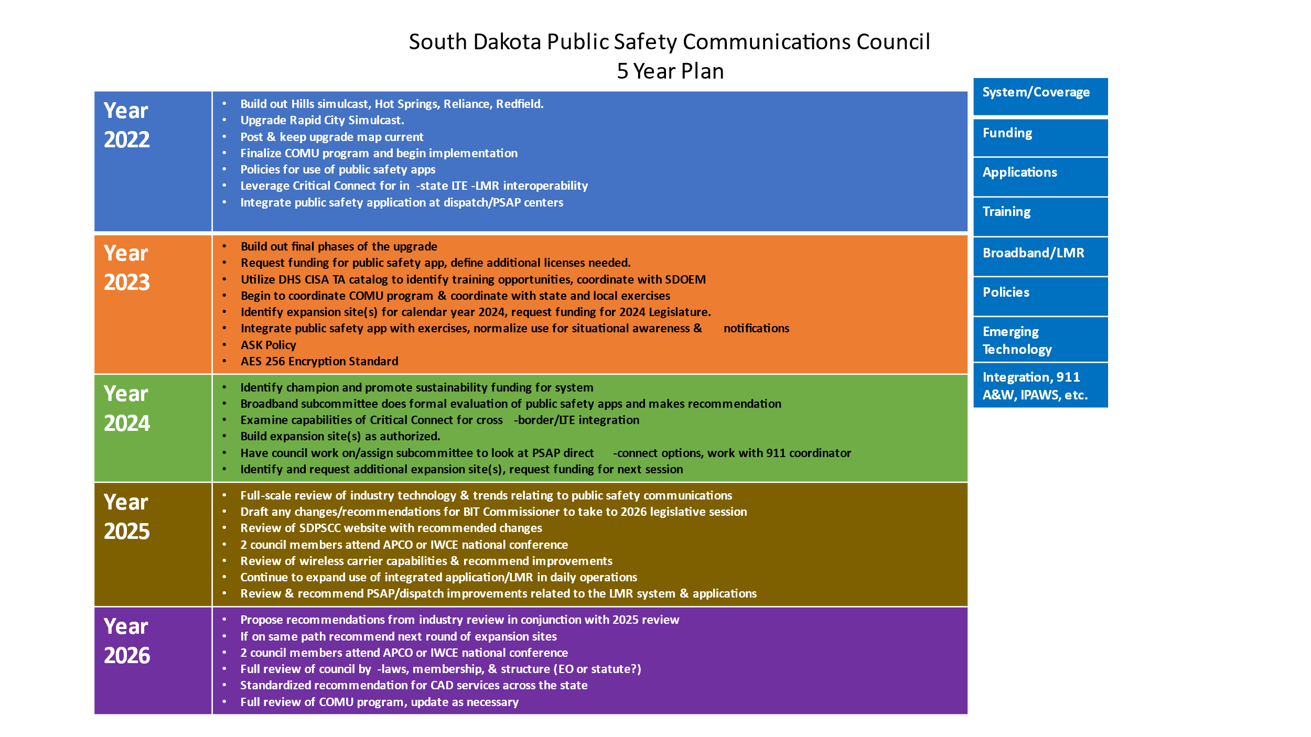

1. **AES Encryption Standard**

* Purchased AES 256 Encryption license from Motorola with EOY funds for dispatches
* Regular meetings with CISA, Pennington County, Minnehaha County, and State Radio
* Currently working on a Draft of the South Dakota Encryption Guide
* We have identified, allocated, and registered 15 KID (Key ID) and CKR (Common Key Reference) numbers for the state issued by the National Law Enforcement Communications Center (NLECC) including a patch key for patching encrypted talkgroups to non-encrypted talkgroups
* NLECC maintains a database of assigned keys to prevent key overlap and conflicts among interop agencies and provides a centralized, secure mechanism for receiving national interoperability keys and unique encryption keys.
* We have reserved counties ranges of KIDs and CKR numbers as well
* Goal to finalize adopt and start using AES 256 standard in Fall of 2023

1. **Strategy for P25 upgrades 2023**

* Continue to effectively pass upgrade information to our affected agencies and organizations
* Outreach and communications to state radio users appears to be successful – not hearing of very many user issues

Organizational Reports

Police Chief’s Assn. - Jason Jones

Sheriffs Assn. - Steve Swenson

DCI - Attorney General – Chad Mosteller

GFP - Bruce Nachtigall

DOT-Vacant

National Guard - David Goodwin

Emergency Managers - Pat Harrington

Firefighters - Charlie Kludt

Healthcare - Tim Rave

Dept. of Public Safety - Garrett Wellman

APCO/NENA - Kevin Karley

EMT’s - JD Geigle

Wildland Fire/DOA – Ray Black

County Commissioners - Gary Jaeger

Health Dept.- Chuck Kevghas

Tribal Governments - Jim Pearson Federal Government - Andy Barth

BIT Engineering - Trent Nincehelser

911 - Maria King

SD House - Vacant

SD Senate – John Wiik

Closing Comments

Vice-chair – Garrett Wellman

Member at Large - Kevin Karley

Chair – Bruce Nachtigall

Next Meeting: date, time, location. Tuesday September 12th?